Quality Management Manual (QM-QM-01)
Release
Action | Role | Date | Name | Signature
Created | Role 1 | YYYY-MM-DD | Mrs. X | Insert digitally
Reviewed | Role 2 | YYYY-MM-DD | Mr. Y | Insert digitally
Released | Role 3 | YYYY-MM-DD | Mrs. Z | Insert digitally

The release table is optional and can be removed when using a cover sheet or a digital document management system.

1 Meta information

1.1 Purpose
This Quality Management (QM) Manual describes the structure of our organization and our QM system. It serves as overview and introduction of our QM documentation. The specific standard operating procedures are described in separate documents.

1.2 Scope
The QM system described in this manual applies for all locations and departments of our company and all medical devices.

1.3 Responsibilities
The general management is responsible for the compilation, updating, and announcement of this manual.

1.4 Addressees
All employees of the company.

1.5 Training
All new employees must be trained in this manual. Management decides whether, if so when, how often and in what form additional training is necessary.

2 General

2.1 Applicable Standards, Directives & Laws

Please find an example below and adapt accordingly.

Our QM system complies with the requirements of the following relevant standards, directives, and laws in the version specified in RU-LIS-01 Regulations to be monitored:
- Medical Device Regulation 2017/745 (MDR)
- 'Medizinprodukterecht-Durchführungsgesetz' and relevant regulations
- EN ISO 13485
- EN ISO 9001
- EN ISO 14971
- EN 62304
- EN 62366-1

For IVD medical devices, the following directive/regulation applies instead of MDR:
- Regulation on in vitro diagnostic medical devices 2017/746 (IVDR)
As well as, if applicable, under the current transition periods for IVD medical devices:
- Directive on in vitro diagnostic medical devices 98/79/EC (IVDD)
- Act on Medical Devices

2.2 Exclusions & Non-Applications

Please find an example below and adapt accordingly.

The following section of the standard ISO 13485:2016 are not applicable for our QM system:
- 7.5.2 Cleanliness of product
- 7.5.5 Particular requirements for sterile medical devices
- 7.5.7 Particular requirements for validation of processes for sterilization and sterile barrier systems
- 7.5.9 Particular requirements for implantable medical devices
Justification for the non-application: We do not produce sterile or implantable medical devices.

2.3 Terms and abbreviations
- CSV Computerized System Validation
- FOR Form
- LIS List
- IVDD Directive on in vitro diagnostic medical devices 98/79/EC
- IVDR Regulation on in vitro diagnostic medical devices 2017/746
- MDD Medical Device Directive 93/42/EWG
- MDR Medical Device Regulation 2017/745
- QM Quality management
- QMM Quality Management Manual
- REC Record
- SOP Standard Operating Procedure (=VA: Verfahrensanweisung)
- TD Technical documentation
- TPL Template
- WI Work Instruction (=AA: Arbeitsanweisung)

Alternatively and prioritized, omit entries here and create a glossary to which reference is made here.

2.4 Linguistic form
Optional chapter:
The templates of the Johner Institute do not (yet) have a uniform, gender-neutral language. Here you can give hints on the linguistic form of your QM-system.
Example: 'In the medium term, we will adapt the linguistic form in our organization's documents to a gender-neutral language. In some documents, the male form has been used so far for personal pronouns. However, this does not imply discrimination against other sexes, but should be understood as gender-neutral in the sense of linguistic simplification.'

3 About us

3.1 Company

Please add here a description of your company, name, industry, field, medical device, services, and company philosophy.

3.2 Quality Policy and Quality Objectives
We describe our quality policy in the document QM-QM-02 Quality Policy.
We describe our quality objectives in the document QM-QM-03 Quality Objectives.

3.3 Organization & Roles

Describe your organizational structure and important roles.
Start with the role/s of your organisation (e.g. manufacturer, distributor, authorised representative, importer, service provider etc.)
Add an organigram and descriptions of the employee's roles (including responsibilities).
Exchange the organigram and complete in more detail and specify roles.

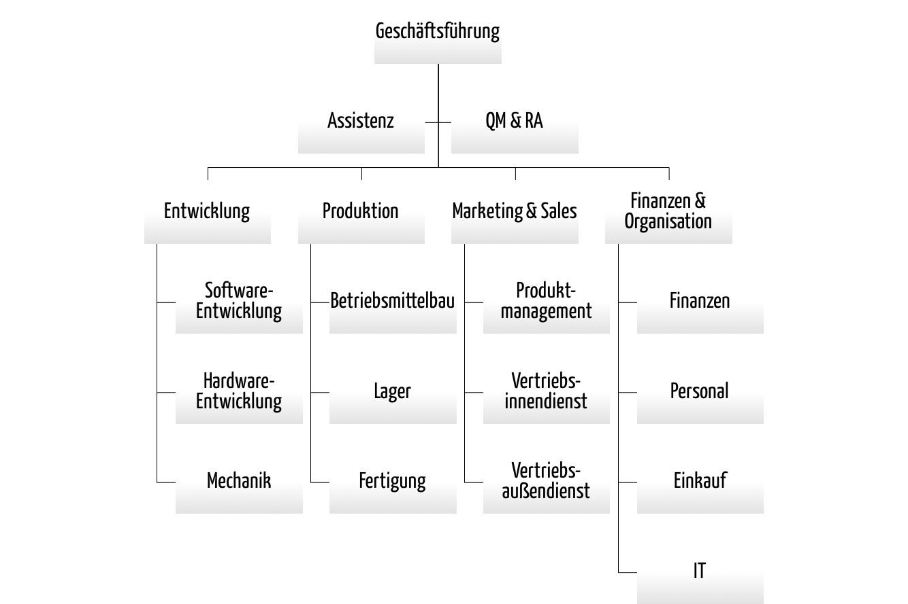
Fig. 1: Organigram
Our role descriptions can be found add reference here.

Alternatively, you can describe the roles 'only' in the SOPs. Please mention this here.

3.4 Infrastructure

Describe the requirements of your infrastructure and how you will adhere to them to achieve compliance with product requirements and to ensure proper handling of the product.
Discuss how to avoid product mix-ups. You can also reference another document.
Describe how and in which intervals you perform maintenance, and where you keep the records of such maintenance activities.
Note: Infrastructure includes buildings, premises, process equipment such as hardware and software, and support services (transport, communication, and information systems).
Alternative: Refer here to the corresponding SOP (IS-SOP-05) and transfer the chapter on infrastructure to chapter 6 'Processes'.

3.5 Work environment and contamination control

3.5.1 Work environment

Describe here the requirements to the work environment necessary to achieve conformity with the product requirements.
If working environment conditions may affect product quality, document the requirements and refer to the Work Environment Monitoring and Contamination Control SOP.
Also describe here the health, cleanliness, and work clothing requirements of personnel, if contact between personnel and product could compromise the medical device's safety/performance.
Discuss how to ensure that all employees, who are temporarily required to work under special environmental conditions in their work environment, are competent or are supervised by a competent person.
Alternative: Refer here to the corresponding SOP (IS-SOP-03 Control and Monitoring of the Work Environment) and transfer the chapter on work environment to chapter 6 'Processes'.

3.5.2 Contamination control

If applicable to your organization, describe here how you manage the control of potentially contaminated products.
In the case of sterile medical devices, describe here how you deal with the control of contamination by microorganisms and particles. Describe how to maintain the required cleanliness during assembly or packaging processes.
Alternative: Refer to the appropriate procedure(s) (PSA-SOP-01) and transfer the chapter on contamination control to chapter 6 'Processes'.

4 QM Documentation Structure
The documentation of our QM system is divided into 4 levels.
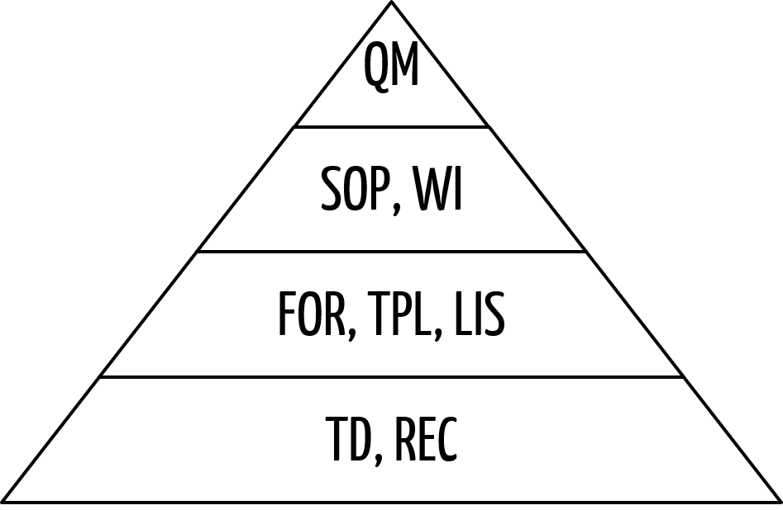
Fig. 2: Document pyramid
The rules for creating, changing and deleting documents are described in SOP DC-SOP-01 Control of Documents and Records.

4.1 Quality Management Manual
This QM Manual (QMM) provides an introduction to the documentation on the highest level. It describes the organization and QM system structure and gives a summary of our processes.

4.2 Standard Operating Procedures and Work Instructions
Standard Operating Procedures and Work Instructions are specification documents.
The Standard Operating Procedures (SOP) describe how we implement certain processes. They include precise descriptions of distinct inputs, activities, responsibilities and results/outputs, respectively.
Work instructions (WI) always belong to a certain SOP. They describe in detail how we execute the specific activities mentioned in the SOP.

4.3 Other Specifications
Forms (FOR) and Lists (LIS) are required by our SOPs and WIs and serve as record of a specific activity when completed.
We use templates (TPL) for the compilation of any kind of document. Templates specify the layout and structure of the document and may include required or recommended sections as default. In particular, we use them for the technical documentation.

4.4 Records
Records (REC) are completed forms (FOR) or extracts from lists (LIS), but also records of the technical documentation (TD) and laboratory books or other (handwritten) quality-relevant records.

5 Risk based approach
We implement the risk-based control of processes through the following activities:
- Identification of processes: We create a selection of our processes that can influence risks in medical devices/IVD. The results of the preliminary hazard analysis (PHA), risk analysis and post-market surveillance help us to identify the processes that can influence risks (extent of damage and probability of occurrence). We document the results in a list with a description of the risk-based approach to each process.
- Risk-based decision in which depth/detail the processes should be described: Based on the risk analysis, we decide which (sub)processes need to be described exactly in order to reduce or avoid risks. If necessary, in addition to SOPs, we create WIs that explain certain activities in detail to avoid errors.
- Based on the risks and the necessary competence to manage them, we decide who is allowed to create, modify, check and release the documents.
- Based on the risks, we decide how often an existing process description (SOP) with all associated documents (WI, FOR, LIS, TPL) must be reviewed and updated if necessary. We use our internal audit process, for example, for this purpose.

The list of processes that influence risks can either be inserted directly here or referred to. Possibly, DC-LIS-04 Document List is suitable for showing the risk-based processes more flexibly.
Examples for appropriate processes are:
- Supplier Selection and Evaluation.
- Computerized System Validation
- Recruiting and Training
- Process Validation

For all documented processes, we have decided on a risk-based basis which responsible employees are allowed to create, change, check and release the specification documents.
All processes are reviewed by internal audits within an audit cycle of one to three years (see audit program).

6 Processes

6.1 Process Overview & Interaction

Graphic Overview

Describe your process organization. Adjust the following example diagram.

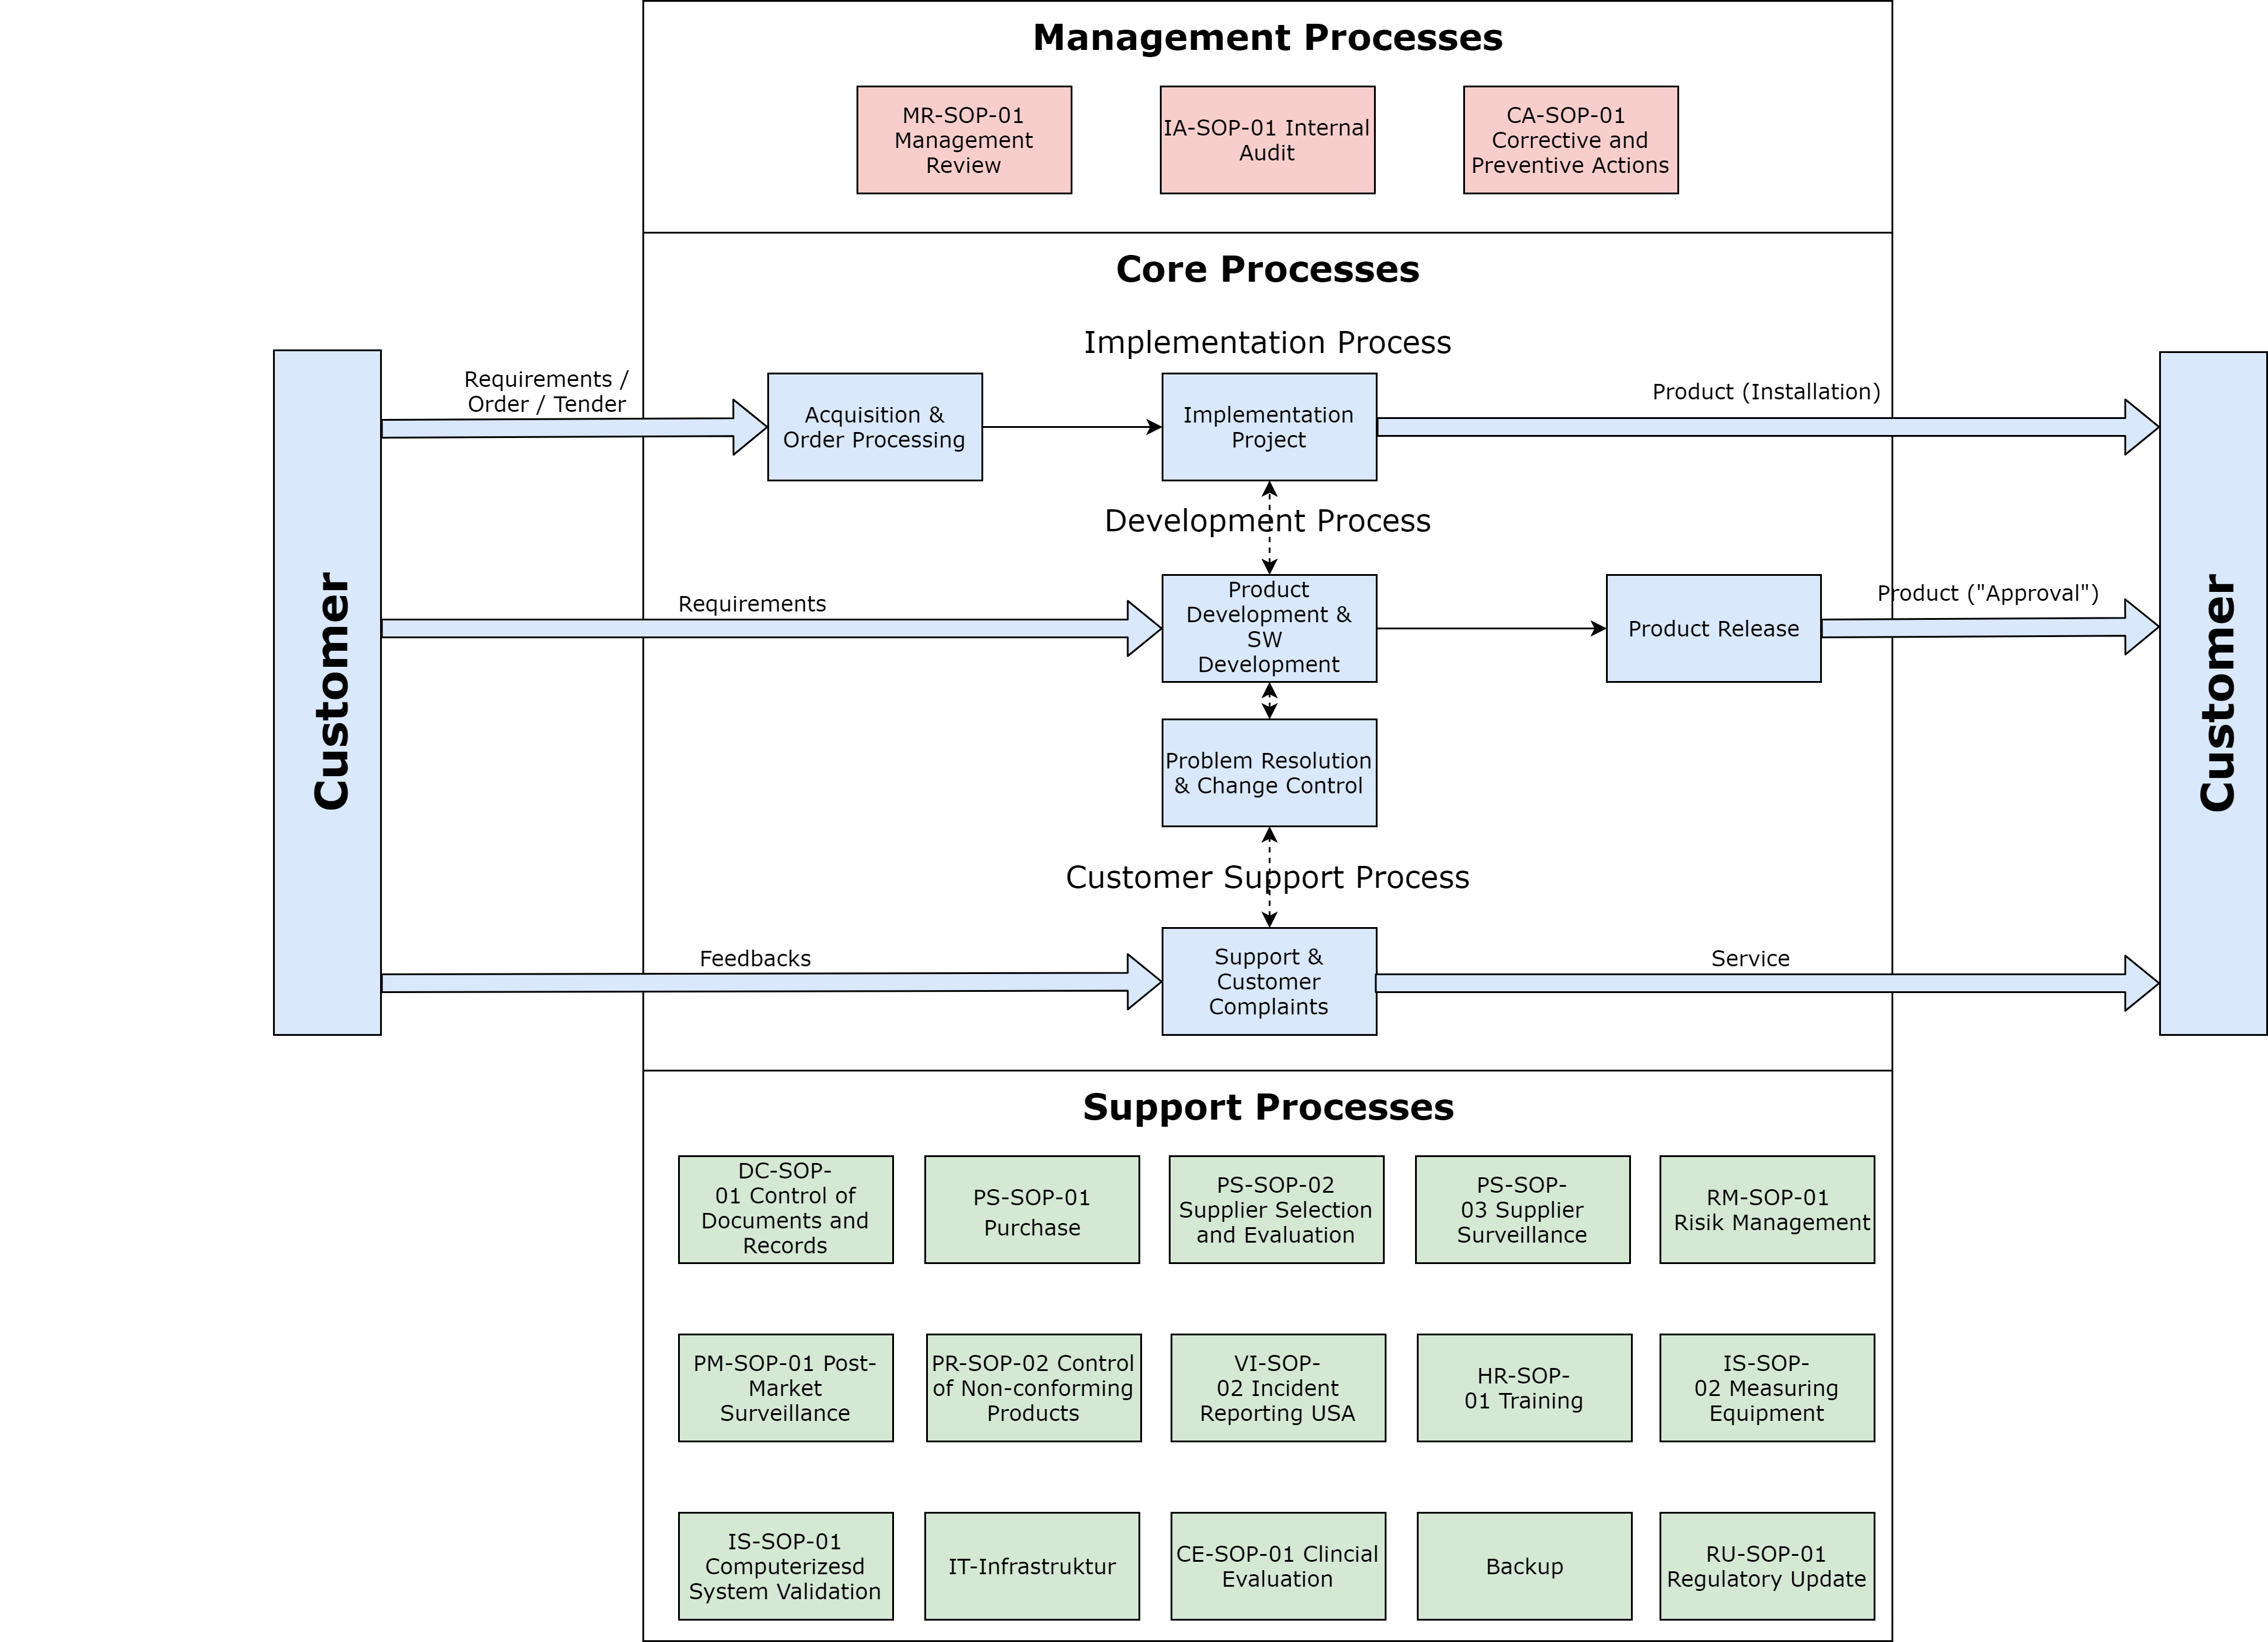
Fig. 3: Process Overview

If necessary, also include outsourced processes in the graphic and mark them separately.

If necessary, adjust the text corresponding to the following example
The following relationships and dependencies are not recognizable in the diagram:
- Influence of the management processes on the core processes
- Support of the management and core processes through the support processes
- Input of the core and support processes for the management processes

Alternatively, a tabular process overview can also be used.

6.2 Individual processes
Based on a risk-based approach, we have decided to create SOPs for the following processes.

the processes listed in the following chapters must be adapted according to the process overview and sorted into Management, Core, and Support Processes.

6.2.1 Management Processes

Data Analysis & Management Review
Our management conducts a Management Review at least once per year and mostly at the beginning of a new business year. During the Management Review, we evaluate, among others, the data analysis results and the achieved objectives within the respective period.
We determine new objectives (quality objectives) for the following period.
We evaluate the efficacy of our QM system and define suitable actions for deficiencies. This is how we strive to a continuous improvement and to maintain the efficacy of the QM system. This process realizes the phases P and C of the PDCA cycle (Plan, Do, Check, Act). This procedure is described in detail in SOP MR-SOP-01 Management Review and MR-SOP-02 Data Analysis.

Internal Audit
We conduct internal audits according to the SOP IA-SOP-01 Internal Audit in regular intervals. In this context, we review if we comply with the described processes/procedures, if they are effective, and if the requirements comply with the standards and laws. We define corrective and preventive actions (see below). They are processed by the responsible person of the audited area.

Corrective and Preventive Actions (CAPA)
If we determine (potential) nonconformities of our QM system or if any other issues require actions, we proceed with Corrective and Preventive Actions as described in SOP CA-SOP-01 Corrective and Preventive Actions. This is how we strive to a continuous improvement and to maintain the efficacy of the QM system. Here, we realize phase A of the PDCA cycle (Plan, Do, Check, Act).

6.2.2 Core Processes

Development
The development process turns customer (and other stakeholder) requirements into finished medical devices that are provided to the customer.
The development is described in the SOP PD-SOP-03 Product Development or SOP SW-SOP-01 Software Development. This process is applied in case of own developments and order developments.

For IVD assay or instrument development, use PD-SOP-02 Product Development IVD-Assay/IVD-Instrument instead of PD-SOP-03.

We process product changes (design and development changes) and significant changes to the QM system according to the SOP CC-SOP-01 Change Control.
Medical devices must be labeled with a CE marking in order to be placed on the EU market. The CE marking shall only be applied to the medical devices by name of the company under specific conditions. The SOP TF-SOP-03 Placing on the market MDR describes the CE marking process and how we ensure that we comply with the respective conditions.

If you place IVD on the market, use TF-SOP-04 Placing on the market acc. to IVDR instead of TF-SOP-03.
If you plan to place products on the market in the USA, use TF-SOP-02 Product Release FDA.

Production
We produce our medical devices according to our SOP PR-SOP-01 Production and validate our production processes according to our SOP PR-SOP-03 Processvalidation.

Sales
The SOP Sales describes how we acquire customers, create quotations, and generate orders. Quotations are customer-specific and are calculated individually. In case of a successful order, we implement our medical devices at the customer. This includes activities such as training, set-up, installation, and acceptance. Details are described in the support processes.

Support
We record and investigate feedback (from customers, as well as from employees through internal processes such as production and service) including customer complaints. We use feedback to determine the compliance with requirements and to improve it (SOP SU-SOP-01 Support). We analyze complaints and determine the cause of a problem. If the issue is related to our medical devices, we proceed according to our SOP CH-SOP-01 Complaint Handling. Especially for software, we use the process described in PD-SOP-01 Problem Resolution for problem solving. We take suitable corrections, corrective and preventive actions (SOP CA-SOP-01 CAPA).

6.2.3 Support Processes
The structure of our QM system documentation and the document life cycle are described in the SOP DC-SOP-01 Control of Documents and Records.
We describe our purchase process in the SOP PS-SOP-01 Purchase. This is how we ensure that only goods and services are purchased that comply in full with our quality standard. With LG-SOP-01 Warehouse and Shipping we ensure that the safety and performance of products in our warehouses, during in-plant transport and shipping is maintained.
We only purchase goods and services from approved suppliers. We only outsource processes to approved suppliers. We conduct supplier evaluations, approvals, and surveillance. The procedure is described in the SOP PS-SOP-02 Supplier Selection and Evaluation and SOP PS-SOP-03 Supplier Surveillance.
We evaluate and minimize identified medical device risks in order to develop safe medical devices. The development process is accompanied by the risk management process from the beginning until the end. We describe the risk management process in the SOP RM-SOP-01 Risk Management.

If you are developing IVD, use RM-SOP-02 Risk Management IVD and, if applicable, RM-SOP-03 Risk Management in Production - IVD instead of RM-SOP-01.

To ensure the usability of our products, we use the process described in HF-SOP-01 Usability Engineering Process.
Since we only want to place biocompatible medical devices on the market and thus ensure product and patient safety, we use the process described in BC-SOP-01 Biocompatibility assessment.
We conduct a post market surveillance to evaluate risks that we get to know only after the termination of the development and, if required, to take actions to minimize risks as described in the risk management process. We describe the details in the SOP PM-SOP-01 Post-Market Surveillance.

If you are developing IVD, use PM-SOP-02 Post Market Surveillance - IVD instead of PM-SOP-01.

The handling of faulty or non-conforming products is described in SOP PR-SOP-02 Control of non-conforming products.
We report incidents and recalls of our medical devices in accordance with SOP VI-SOP-03 Reporting of Incidents & FSCA in the EU acc. to the MDR and VI-SOP-02 Incident Reporting & Recalls USA.
The SOP HR-SOP-01 Recruiting and Training describes how we ensure the provision of sufficient and competent employees, including a training needs analysis and the conduct of training.
We carry out necessary maintenance at our customers according to the SOP Service and Installation.
We control our measuring devices according to the SOP IS-SOP-02 Measuring Equipment. The control of our measuring devices includes the labeling, verification, and handling of erroneous measuring devices.
We validate software measuring devices and software that we use within our QM system according to the SOP IS-SOP-01 Computerized System Validation.
The SOP LA-SOP-02 Labeling and Tracking of Products describes the labeling and traceability of our medical devices during the development and after sales. Our systematic labeling always enables a clear identification. We also ensure the traceability regarding which customer received which medical device .
General requirements to our IT infrastructure to ensure that it does not affect the quality of our medical devices and the conformity with regulatory requirements are described in the SOP IT infrastructure.
The SOP CE-SOP-01 Clinical Evaluation describes how we conduct clinical evaluations for our medical devices. The process for the follow-up is described in CF-SOP-01 Post-Market Clinical Follow-Up.

In case of IVDs, please use the following text: The SOP PE-SOP-01 Performance Evaluation describes how we conduct performance evaluations and the follow-up for our IVD medical devices.

Our data backup is regulated by the SOP Backup.
The SOP RU-SOP-01 Regulatory Update describes how we inform ourselves about new or changed regulatory requirements and how we react to them.

7 General Regulations

7.1 Communication

Describe here general regulations for the internal communication and customer communication.

7.2 Customer Property

Describe here the regulations for the handling of patient data (data protection). E.g.: We define patient data as customer property and treat it as confidential and do not provide it to third parties.

8 Annex

8.1 Relevant Documents
All documents of the quality management system are applicable documents of the QM Manual.
The applicable documents as well as their version and validity date are documented in DC-LIS-04 Document List.

If DC-LIS-04 is not used, please add a table according to the following example and fill it with all applicable documents:
No. | Document ID | Description
01 | QM-QM-02 | Quality Policy
02 | ... | ...

8.2 Version history
Version | Effective date | Author | Change description
01 | 2017-08-20 | CJ | First Version
02 | 2017-08-23 | RDH | Updating and error corrections
03 | 2019-01-03 | UH | Standardization of the structure and error corrections
04 | 2019-07-17 | UH | New or changed points: Roles of the organization added; Support section: feedback more precise; customer communication added; risk-based approach added; QM system changes added
05 | 2019-09-23 | UH | Addition of chapters 3.4 Infrastructure and 3.5 Work environment and contamination control
06 | 2020-01-09 | UH | Extension to the risk-based approach in Chapters 5 and 6.2, additions to outsourced processes in Chapter 6.1 and Chapter 6.2.3
07 | 2020-02-26 | UH | Adjustment of the document pyramid (Chapter 4) - Technical documentation placed at the level of the records
08 | 2020-07-30 | UH | More precise description of chapter 5 Risk-based approach
09 | 2021-09-29 | UH | Reference to TF-SOP-01 replaced by reference to TF-SOP-03
10 | 2022-01-19 | SB | Applicable Standards, Directives & Laws updated, reference to RU-LIS-01 added
11 | 2022-02-11 | BT | Reference IS-SOP-03 added
12 | 2022-04-19 | UH | IDs added to named SOPs; Chapter 8.1: Table replaced by reference to DC-LIS-04; References to previously unreferenced templates added throughout the document.
13 | 2022-06-01 | BT | Reference to new SOP on contamination control (PSA-SOP-01) added to chapter 3.5.2
14 | 2022-10-25 | BT | Reference to new SOP on infrastructure (IS-SOP-05) added to chapter 3.4
15 | 2023-01-31 | BT | Reference to new SOP on process validation (PR-SOP-03) added in chapter 6.2.2 Core processes
16 | 2023-05-11 | UH | Reference to new SOP on storage and shipping (LG-SOP-01) added to chapter 6.2.3

This is the template version history of the Johner Institute. Clean up the table if necessary and use it for your document control purposes.

